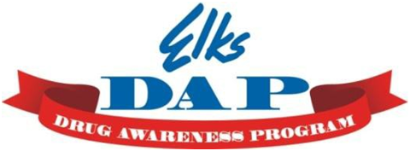

MD, DE, DC Elks Drug Awareness Program Literature Order form

These items are provided by the Elks National Drug Awareness Program to your Lodge at no charge. Once form is completed by the Lodge Drug Awareness Chairperson, Lodge Secretary, or Exalted Ruler, forward it on to the State Drug Awareness Chairperson.
Lodge Info Information about the lodge you are ordering literature for.
Lodge Name:__________________
Lodge Number:__________________

Shipping Address
Please include a complete address, including a lodge or contact name. Shipments are by UPS, so be sure to give a street address, not a P.O. Box. Missing information will delay processing!
Contact:__________________________
Address: ____________________
Address (2): ___________________________ City: __________________
State:___________ Zip code: ___________
__ Residential Address __Business Address

For Use (select one):
__ Trailer __ School __ Special Event __ Law Enforcement __ Other

Ordering Materials for (select one):
__ Lodge (max order 500) __ District Chair (max order 1000) __ State Chair (max order 2000)

Email Completed Form to: Angela M. Meyer, State Chairman
Elks Drug Awareness Programs
MD, DE, DC Elks Association
ecbsecretary@outlook.com
410-224-2945 (O) 410-739-5575 (cell)

Your Order: Please use full box count only.

Boxes Desired | Amt. Per Pack | Code & Name
 | 250 | DAP110: Underage Drinking - Myths and Facts
 | 250 | DAP165: Coloring Book
 | 250 | DAP170: How Can I Tell If My Child Is Using Drugs?
 | 250 | DAP200: Tips for Teens - Tobacco
 | 250 | DAP230: Bookmarks
 | 250 | DAP265: Kids, Cars and Marijuana
 | 250 | DAP270: Binge Drinking 250
 | 250 | DAP275: Legalizing Marijuana
 | 50 | DAP280: Elks National Drug Awareness Program
 | 1 | DAP310: Parenting is Prevention Flash drive
 | 1 | DAP330: Video - UR Choice, UR Voice
 | 250 | DAP350: Prescription Drugs
 | 250 | DAP360: Marijuana Facts
 | 250 | DAP370: Heroin
 | 250 | DAP380: Impaired Driving
 | 250 | DAP385: Ecstasy & Molly
 | 250 | DAP390: K2/Spice
 | 250 | DAP395: DXM
 | 250 | DAP400: Methamphetamine
 | 50 | DAP405: Elks Drug Quiz
 | 250 | DAP410: Heroin-Fentanyl
 | 250 | DAP420: Vaping
 | 250 | DAP430: Red Ribbon History
 | 250 | DAP435: Bullying & Drug Abuse: The Connection
 | 250 | DAP440: Stress & Drug Abuse

